Business Requirements Document (BRD)
Project: Customer Shopping Behaviour Analysis

Project Overview
This project focuses on understanding customer shopping behavior using data from 3,900 individual purchase transactions. The analysis covers different product categories and looks at how customers spend, what they prefer to buy, and how they respond to subscription offers. The study aims to break down buying patterns and identify meaningful customer groups based on age, income, purchase frequency, and product choice. It also reviews subscription behavior to understand who is most likely to subscribe, what influences the decision, and how subscriptions impact revenue. The key purpose of this project is to help the business make informed decisions. By exploring customer preferences, high performing product categories, seasonal buying trends, and factors affecting customer retention, the findings will support improvements in marketing, pricing, product mix, and loyalty programs. The insights gained from this analysis can guide strategies that increase customer engagement, repeat purchases, and overall business growth.

Business Objectives
- Understand Customer Spending Behavior
Analyze how customers allocate their spending across different product categories to identify high revenue contributors and low-performing categories.
- Identify Customer Segments
Group customers based on demographics such as age and income, along with purchase frequency and product preferences, to build targeted marketing and sales strategies.
- Evaluate Subscription Performance
Study subscription adoption patterns to understand which customer segments are most likely to subscribe, key factors influencing subscription decisions, and the impact on long-term revenue.
- Enhance Customer Retention
Examine buying patterns, repeat purchase trends, and customer satisfaction drivers to improve retention and reduce churn.

Dataset Summary
Dataset Summary - Rows: 3,900 - Columns: 18 - Key Features: - Customer demographics (Age, Gender, Location, Subscription Status) - Purchase details (Item Purchased, Category, Purchase Amount, Season, Size, Color) - Shopping behavior (Discount Applied, Promo Code Used, Previous Purchases, Frequency of Purchases, Review Rating, Shipping Type) - Missing Data: 37 values in Review Rating column.

Exploratory Data Analysis using Python
We began with data preparation and cleaning in Python:
● Data Loading: Imported the dataset using pandas.
● Initial Exploration: Used df.info() to check structure and df.describe() for summary statistics.

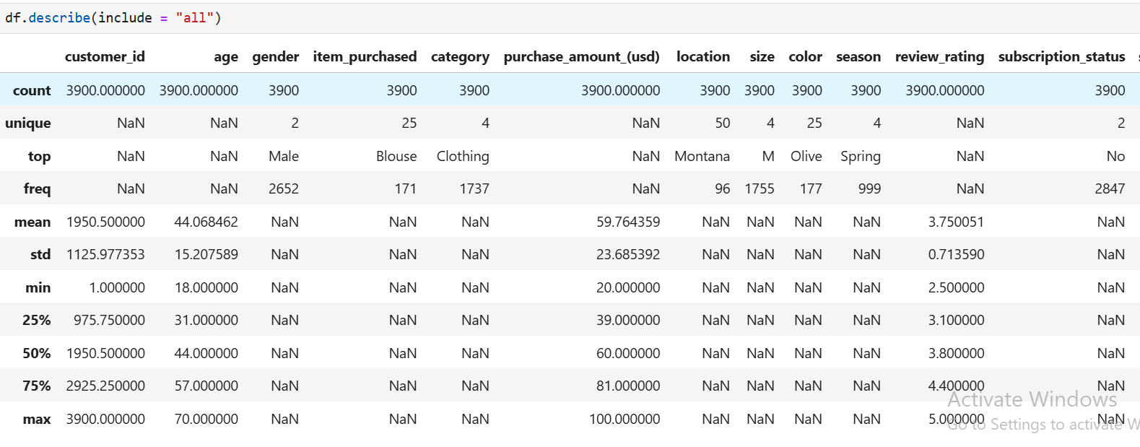

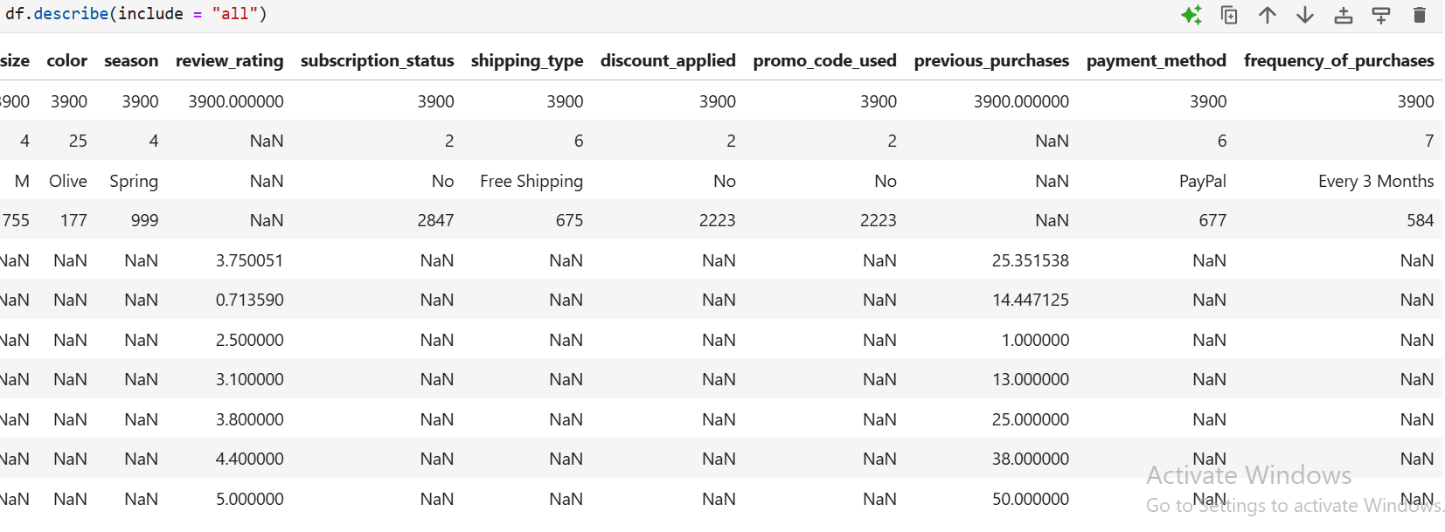

Missing Data Handling: Checked for null values and imputed missing values in the Review Rating column using the median rating of each product category.

Column Standardization: Renamed columns to snake case for better readability and documentation.

Feature Engineering: Created age_group column by binning customer ages.
Created purchase_frequency_days column from purchase data.

Data Consistency Check: Verified if discount_applied and promo_code_used were redundant; dropped promo_code_used.

Database Integration: Connected Python script to MySQL and loaded the cleaned DataFrame into the database for SQL analysis.

Data Analysis using SQL (Business Transactions)
Performed structured analysis in PostgreSQL to answer key business questions:
1. Revenue by Gender – Compared total revenue generated by male vs. female customers.
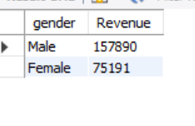

2. High-Spending Discount Users – Identified customers who used discounts but still spent above the average purchase amount.
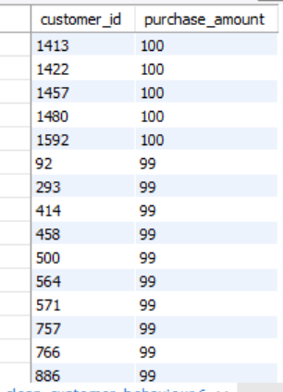

3. Top 5 Products by Rating – Found products with the highest average review ratings
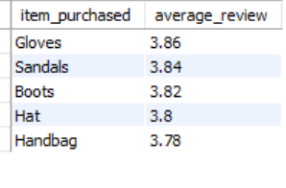

4. Shipping Type Comparison – Compared average purchase amounts between Standard and Express shipping.
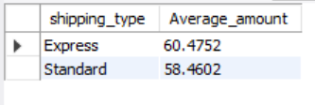

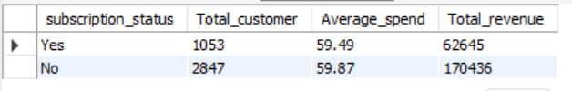
5. Subscribers vs. Non-Subscribers – Compared average spend and total revenue across subscription status.

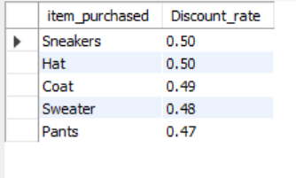
6. Discount-Dependent Products – Identified 5 products with the highest percentage of discounted purchases.

7. Customer Segmentation – Classified customers into New, Returning, and Loyal segments based on purchase history.
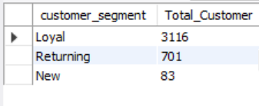

8. Top 3 Products per Category – Listed the most purchased products within each category.
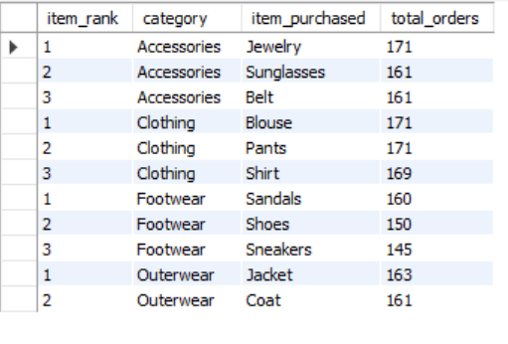

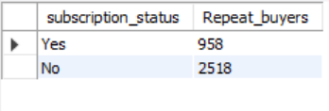
9. Repeat Buyers & Subscriptions – Checked whether customers with >5 purchases are more likely to subscribe.

10. Revenue by Age Group – Calculated total revenue contribution of each age group.
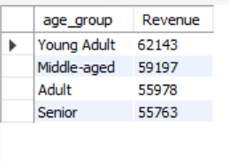

Analysis & Visualizations
Dashboard in Power BI
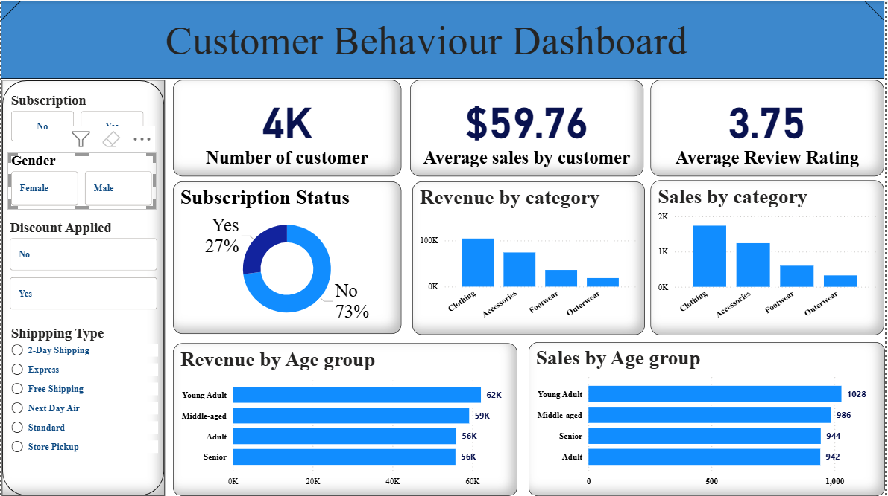

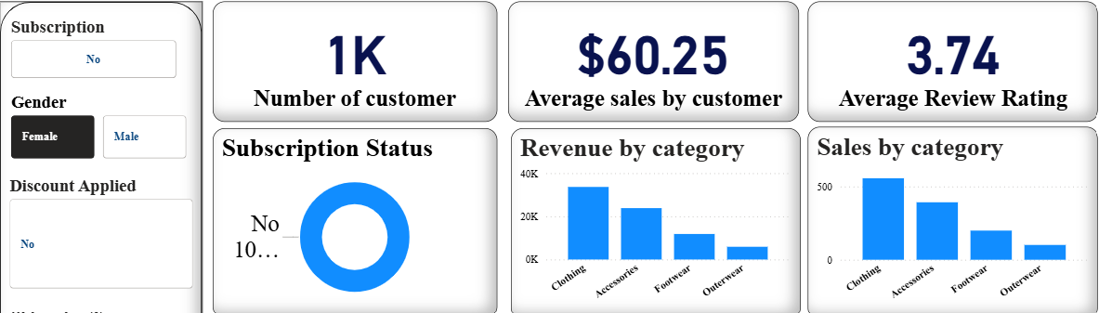

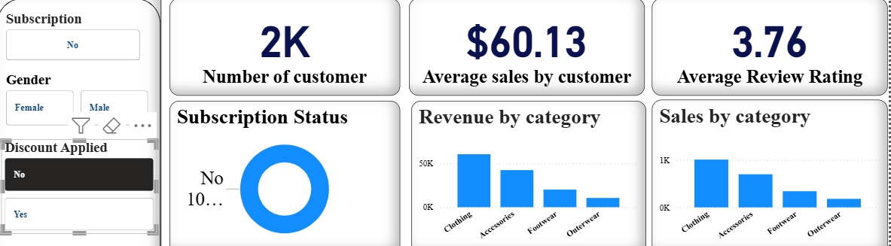

Insight:-
- Total customers: 4K, with an average spend of $59.76 per customer but the average spending of a female customer is $60.25, slightly higher than the overall average.
- Average rating is 3.75, showing moderate satisfaction and scope to improve service.
- Only 27% customers have subscriptions. Large potential to convert the remaining 73% especially female customers and non-discounted customer.
- Clothing is the top performing category, both in revenue and number of sales across all segments. Accessories rank second in both revenue and sales. Footwear and Outerwear show low demand, indicating a need for promotional strategies, seasonal campaigns, or product updates to improve performance.
- Young Adults as the most profitable and active segment, followed by Middle-aged customers.

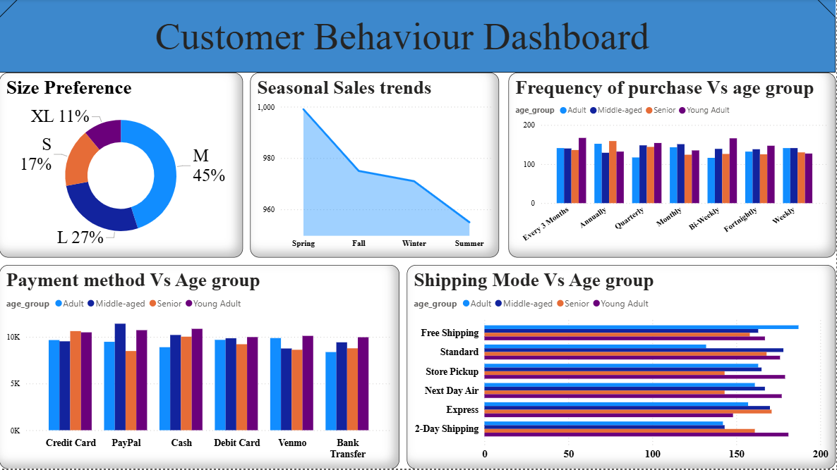

Insight:-
- Medium (45%) is the most preferred size, followed by Large (27%). Small (17%) and XL (11%) have lower demand, which helps in planning inventory with a focus on M and L stock.
- Sales peak in Spring, then steadily decline through Fall, Winter, and reach the lowest in Summer.
- Across all Repeat sales (Monthly, Weekly, Annual etc.), Young Adults consistently generate the highest revenue, followed by Middle-aged customer.
- Young Adults spend the most across almost all payment methods. Top payment choices across all age groups are Credit Card and PayPal, followed by Cash and Debit Card. Venmo and Bank Transfer are the least used.
- Free Shipping is the most preferred mode across all age groups, especially Adults and Young Adults. Standard Shipping is the second most used. 2-Day Shipping and Express Shipping are used less often, showing that customers value savings over speed. Store Pickup and Next Day Air are less popular, indicating most shoppers prefer home delivery.

Recommendations

Boost Subscription Conversions
- Promote clear benefits like exclusive discounts, early access, or loyalty points to convert the 73% non-subscribed customers.
- Target subscription campaigns at Young Adults and Middle-aged customers specially female customers, as they show the highest spending and engagement.

Improve Low-Performing Product Categories
- Increase focus on Footwear and Outerwear through seasonal promotions, influencer tie-ups, or improving product designs and styles.
- Bundle slow-moving items with high-demand products to improve conversion.

Enhance Customer Experience and Rating
- Aim to lift the review rating from 3.7 to 4.2+ by improving product quality, customer support, and return/refund experience.
- Track key feedback themes and address common complaints with specific action plans.

Seasonal Sales Strategy
- Summer needs aggressive promotions such as end-of-season sales, combo offers, or limited-time coupons.
- Use Spring momentum for new launches and subscription pushes.

Optimize Inventory and Product Planning
- Prioritize stock for Medium (45%) and Large (27%) sizes to reduce dead inventory.
- Keep limited inventory for Small and XL but offer customization or pre-orders to avoid stock-outs.

Strengthen Delivery and Payment Experience
- Keep Free Shipping as a core offering. Consider thresholds like “Free Shipping above $50” to increase basket size.
- Since Credit Card and PayPal are top picks, continue promoting digital payments with cashback or reward incentives.

Personalized Targeting by Age Group
- Young Adults: Loyalty programs, trend-based products, subscription offers.
- Middle-aged: Value packs, comfort-focused clothing, family bundles.
- Adults & Seniors: Simple UX, trust-building communication, easy return policies.

